Multi-Variate Anomaly Detection in Non-Timeseries data

Subbarao Ramayanam, Software Engineer

Keywords: Anomaly, Anomaly Detection, Multi-variate

What are Anomalies?
- Anomalies are occurrences that deviate from the predictions of economic or financial models that undermine those models' core assumptions.
What is Anomaly Detection?
- It is a process of finding an unusual point or pattern in a dataset.
- With several thousand things to watch, anomaly detection can help figure out where the error is occurring, thereby improving root cause analysis and quickly bringing notice to tech support.
- Anomaly detection helps track and identify the root cause of chaos engineering by identifying the outliers and informing the tech support to act.
- These observations have been related to noise, erroneous or unwanted data, which by itself isn’t interesting to the analyst.
- The anomaly detection problem for time series is usually formulated as identifying outlier data points relative to some norm or usual signal.
What is Non Time Series Data:
- Data that does not have time as a variable is non time series data.
- Data collected by an event-based data collection system are not time series unless events happen deterministically at constant time intervals.
Anomalies vs Outliers:
- Anomalies are patterns of different data within given data, whereas outliers are would be extreme data points within data.
- Outlier: a value that you predictably find in your data that indicates your model does not work properly.
- Anomaly: a value that against all odds you find in your data that indicates your model does work properly.

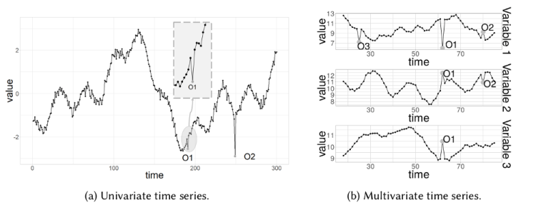
Types of Anomalies:

Univariate Anomaly Detection:
  - Univariate anomaly detection method in which we detect outliers from a distribution of values in a single feature space.
  - That is, spotting outliers for one variable at a time.
  - However, Univariate analysis can only get us thus far. We may realize that some of these anomalies that determined by our models are not the anomalies we expected.
  - When our data is multidimensional as opposed to univariate, the approaches to anomaly detection become more computationally intensive and more mathematically complex.

Multivariate Anomaly Detection:
  - Most of the analysis that we end up doing are multivariate due to complexity of the world we are living in.
  - In multivariate anomaly detection, outlier is a combined unusual score on at least two variables.
  - Multivariate Anomalies occur when the values of various features, taken together seem anomalous even though the individual features do not take unusual values.
  - Detecting a Multivariate Outlier involves examining the values of all the features simultaneously and verifying if the combination of values taken by the features is unusual.
  - As we can understand this becomes intractable to do manually when we have large number of features (say hundreds).
  - Alternately, we can use specialized algorithms that can identify them for us.

Benefits of Anomaly Detection:
- Intrusion Detection
- Ecosystem Disturbances
- Data Cleansing
- Event Detection in Sensor Networks
- Fraud Detection
- System Health Monitoring
- Highlight unusual network traffic

Challenges in Anomaly Detection:
- Unknowingness
- Heterogeneous anomaly classes
- Rarity and class imbalance
- Low anomaly detection recall rate
- Anomaly detection in high-dimensional and not-independent data
- Data-efficient learning of normality and abnormality
- Noise-resilient anomaly detection
- Anomaly explanation and accuracy

How to deal with the anomalies?
There are so many ways to deal with the anomalies.
- Understanding the business case
- Statistical methods to adjust outliers
- Using mean to smoothen out the outlier
- Removing the Outlier

Anomaly detection techniques for Multivariate data:

1.Isolation Forest:
- Isolation Forest is similar in principle to Random Forest and is built on the basis of decision trees.
- Isolation Forests detects anomalies purely based on the fact that anomalies are data points that are few and different.
- The anomalies isolation is implemented without employing any distance or density measure.
- Isolation Forest isolates observations by randomly selecting a feature and then randomly selecting a split value between the maximum and minimum values of that selected feature.
- We can use the Isolation Forest algorithm to predict whether a certain point is an outlier or not, without the help of any labeled dataset.
- Isolation forests work well even for data having hundreds of dimensions.

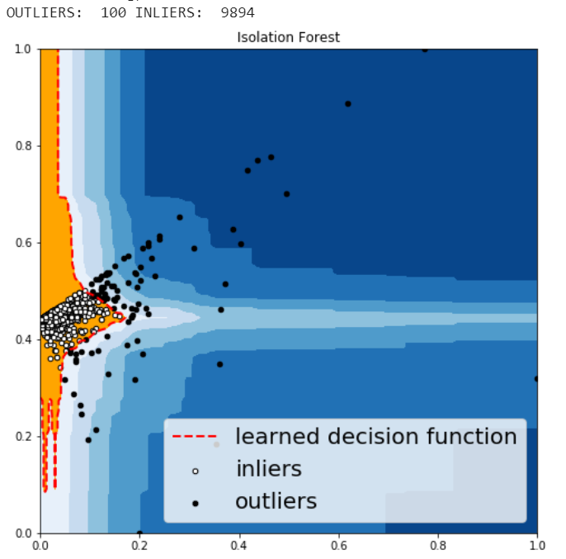

2.Cluster-based Local Outlier Factor (CBLOF):
- The CBLOF calculates the outlier score based on cluster-based local outlier factor.
- An anomaly score is computed by the distance of each instance to its cluster center multiplied by the instances belonging to its cluster.
- Data instances that fall outside of defined clusters could potentially be marked as anomalies.
- Following is the process in this method:
  - Arbitrarily set outliers fraction as 1% based on trial and best guess.
  - Fit the data to the CBLOF model and predict the results.
  - Use threshold value to consider a data point is inlier or outlier.
  - Use decision function to calculate the anomaly score for every point.

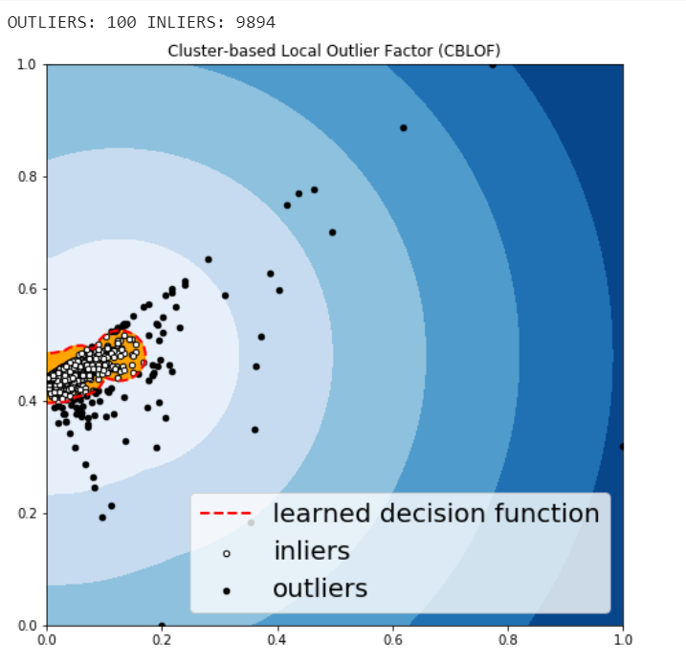

3.Histogram-based Outlier Detection (HBOS):
- HBOS assumes the feature independence and calculates the degree of anomalies by building histograms.
- In multivariate anomaly detection, a histogram for each single feature can be computed, scored individually and combined at the end.

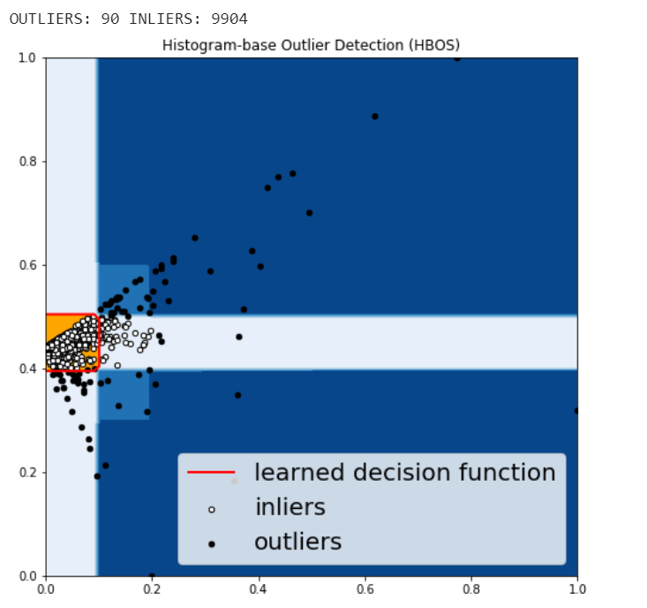

4.K - Nearest Neighbors (KNN):
- KNN is one of the simplest methods in anomaly detection.
- For a data point, its distance to its kth nearest neighbor could be viewed as the outlier score.

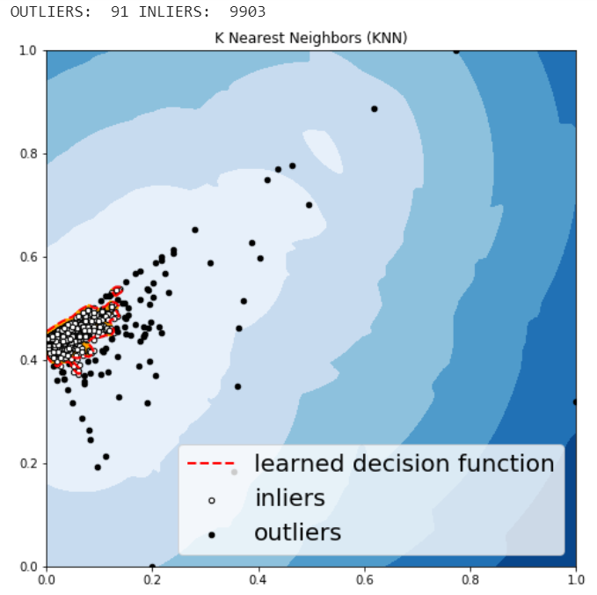
5.One Class - Support Vector Machine(OC-SVM):
- The OC-SVM is a multivariate method that belongs to the family of One-Class classification methods.
- We decide a fraction of data say Ʋ (Pronounced Nu) that we suspect to be the upper bound on the number of anomalies present in data.
- The OC-SVM then tries to find a boundary that encloses regions of high data density excluding at most a fraction Ʋ of data points.
- It can be seen that boundaries which are linear in the problem variable space are too simple for most problems.
- Since SVM is a linear classifier by nature, we need to resort to kernel methods to build a flexible model with non-linear boundaries.

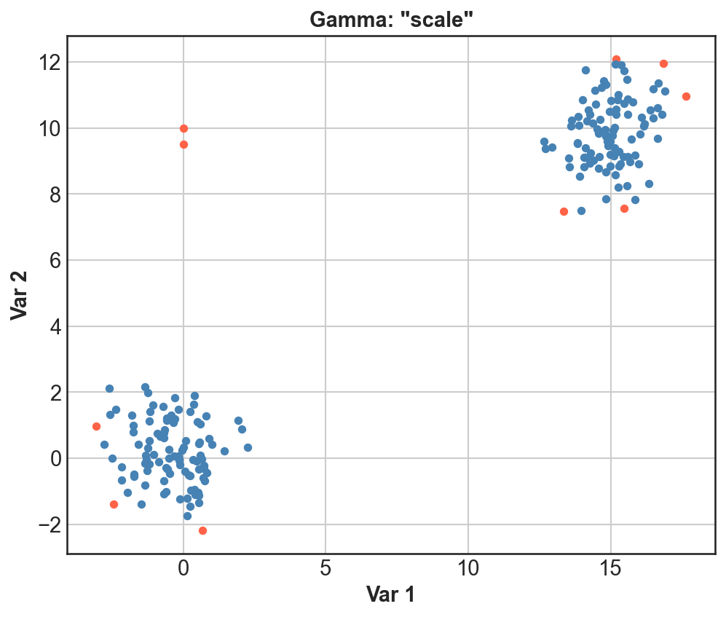

Conclusion:

This overview should give a good idea of what anomaly detection is, difference between univariate and multivariate anomaly detection, why it’s necessary for your business, methods which are used to perform Multivariate Anomaly detection. One of the advantages of this methods is that they do not require the data to belong to a particular distribution. Businesses have been laser-focused on optimizing data collection and now it’s time to use that data to gain insights.

References:
- https://docs.microsoft.com/en-us/learn/modules/identify-abnormal-time-series-data-anomaly-detector/
- https://en.wikipedia.org/wiki/Anomaly_detection
- https://towardsdatascience.com/anomaly-detection-for-dummies-15f148e559c1
- https://towardsdatascience.com/anomaly-detection-in-python-part-2-multivariate-unsupervised-methods-and-code-b311a63f298b


About Author:
Subbarao Ramayanam holds Master’s Degree in Computer Applications from SRKR College Bhimavaram. He is currently working as Software Engineer with ERS Research team and involved in Data Engineering products development.

